PRECOG -
The Ghost in the Machine

- Task 3 error analysis only looked in one direction — Human paragraphs the model wrongly called "AI" (false positives). I did not get to the reverse direction (AI paragraphs wrongly called "Human", i.e. cases where "the AI was being particularly brilliant").
- Task 4's Genetic Algorithm goal of reaching a >90% "Human" confidence score was not achieved. My best result across 5 generations was about 29% Human-probability. I see this as a genuine (negative) research finding rather than a failure to report
Task 0 — The Library of Babel (Building the Dataset)
Steps Performed-
- Downloaded 6 novels from Project Gutenberg: 3 by Arthur Conan Doyle (A Study in Scarlet, The Hound of the Baskervilles, The Sign of the Four) and 3 by H. G. Wells (The Invisible Man, The Time Machine, The War of the Worlds).
- Cleaned each file by stripping the Project Gutenberg license header/footer text using regex.
- Identified 5 topics by simple keyword matching: Crime and Justice, Scientific Discovery and Technology, Human Nature and Morality, Class/Society/Social Evolution, and Imperialism and Colonialism.
- Sampled 50 Human paragraphs per topic (250 total) to form Class 1.
- Used the Gemini API to write 50 plain AI paragraphs per topic (250 total) on the same 5 topics — Class 2 (AI-Normal).
- Used the Gemini API again, this time prompting it to write in the style of Charles Dickens, to get 50 stylized paragraphs per topic (250 total) — Class 3 (AI-Stylized).

Class | Source | Paragraphs
Class 1 — Human | Conan Doyle novels (Project Gutenberg) | 250
Class 2 — AI-Normal | Gemini, plain prompt, same 5 topics | 250
Class 3 — AI-Stylized | Gemini, prompted to imitate Charles Dickens | 250

Task 1 — The Fingerprint (Proving the Classes Are Different)
Steps Performed-
- Imported required Python libraries such as pandas, numpy, nltk, spaCy, matplotlib and textstat.
- Loaded the cleaned dataset containing text samples and labels.
- Preprocessed the text by removing unwanted characters and tokenizing sentences and words.
- Extracted stylometric features including Type-Token Ratio (TTR), Hapax Legomena count, Average Sentence Length, Punctuation Density, Flesch Reading Ease and Flesch-Kincaid Grade Level.
- Generated descriptive statistics and visualizations for feature comparison.
- Saved the final feature dataset for further classification tasks.

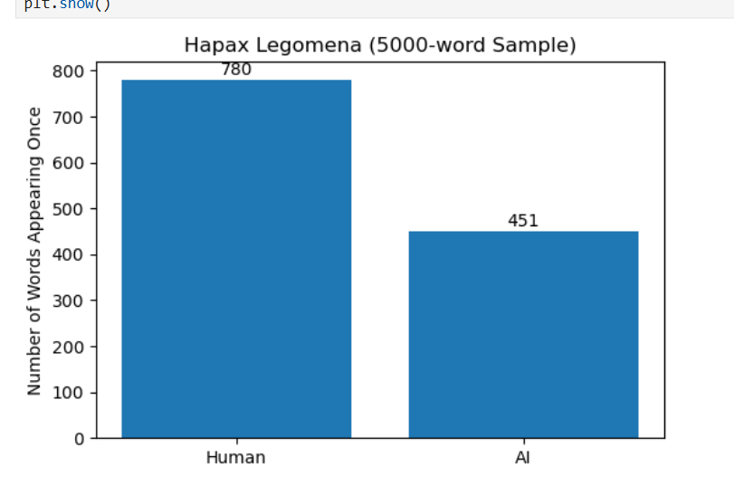

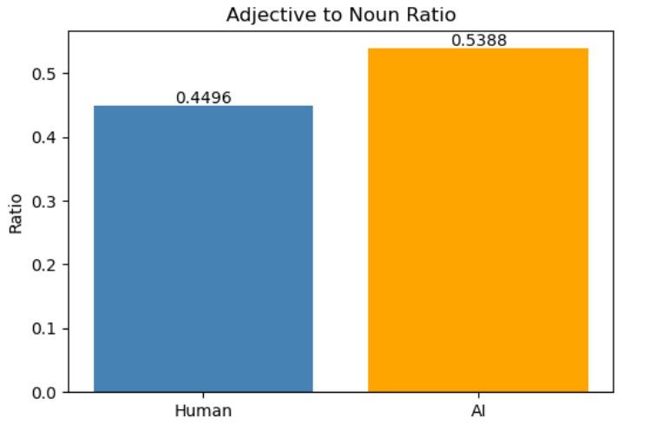

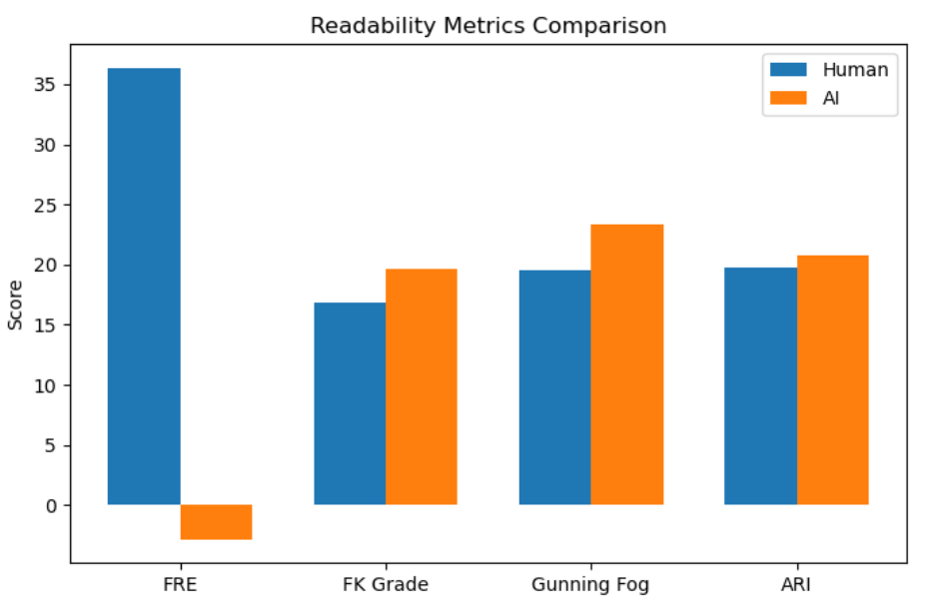
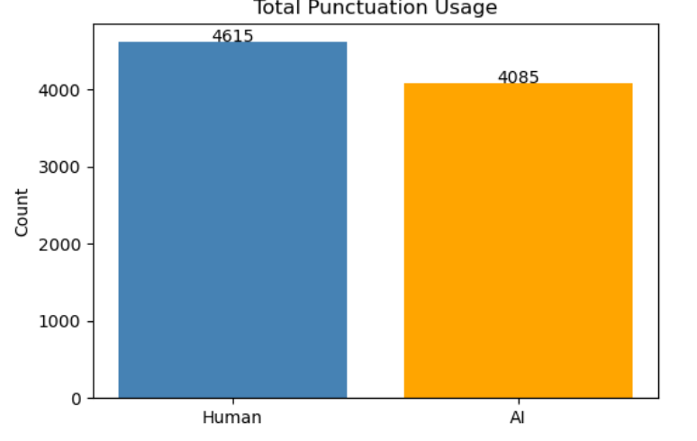

Conclusion-
In this task, we extracted different writing style features from the text dataset and compared them. The results show that every author has a unique writing style. These features can be used in the next tasks to build machine learning models for authorship analysis and AI text detection.

Task 2 – Tier A Report (The Statistician)

The objective of this task is to classify human-written and AI-generated text using machine learning models trained on the numerical writing features extracted in Task 1.
Steps Performed-
- Loaded the stylometric features extracted in Task 1.

Prepared the training and testing datasets.

Trained a Random Forest/XGBoost classifier using these numerical features.

Evaluated the model using accuracy and classification metrics.

Analyzed the model's performance on unseen data.

Tool Used-

Random Forest

Results-

The model was successfully trained using the extracted writing features.

It was able to distinguish between human-written and AI-generated text with good accuracy.

The evaluation metrics helped measure the model's performance.

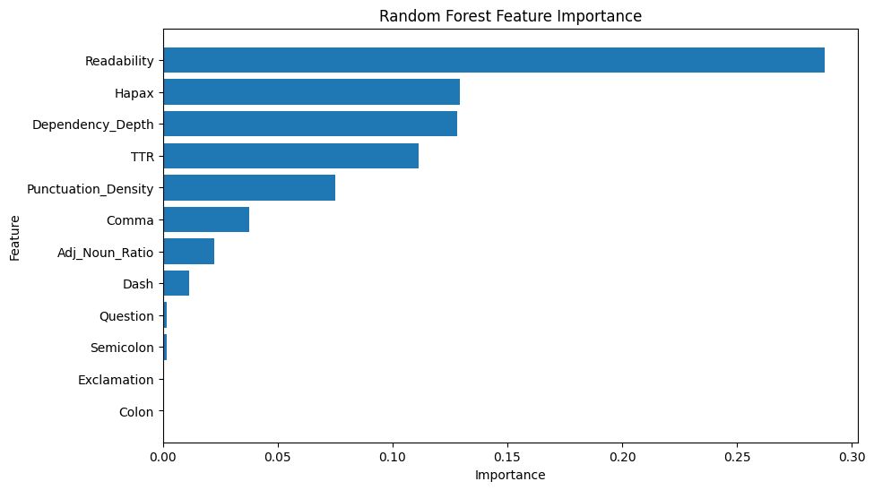

Observations-

Stylometric features are useful for detecting writing style differences.

Some texts were difficult to classify because their writing patterns were similar.

Conclusion-

This task showed that simple numerical writing features can be used to identify AI-generated text. The model achieved good performance and provided a strong baseline for the later models.

Task 2 – Tier B Report (The Semanticist)

The objective of this task is to classify human-written and AI-generated text using semantic word embeddings and a Feedforward Neural Network.
Steps Performed-

Loaded the text dataset.

Converted each paragraph into vector representations using pre-trained GloVe/FastText embeddings.

Calculated the average embedding for every paragraph.

Trained a Feedforward Neural Network on these embeddings.

Evaluated the model using the test dataset.

Tool Used-

GloVe

Results-

The neural network learned semantic patterns from the text.

It successfully classified most human-written and AI-generated paragraphs.

The model performance was evaluated using accuracy and loss values.

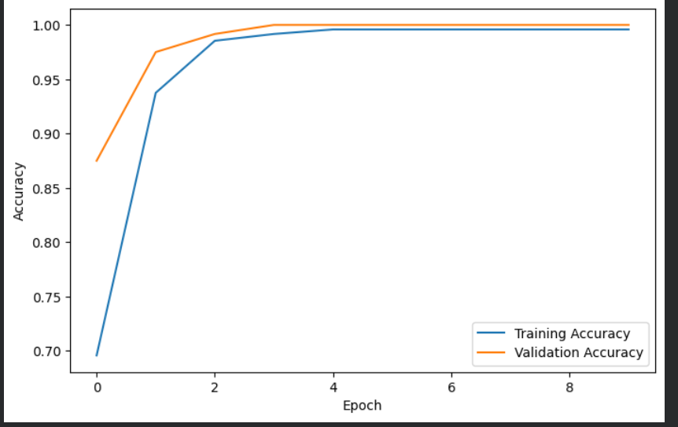

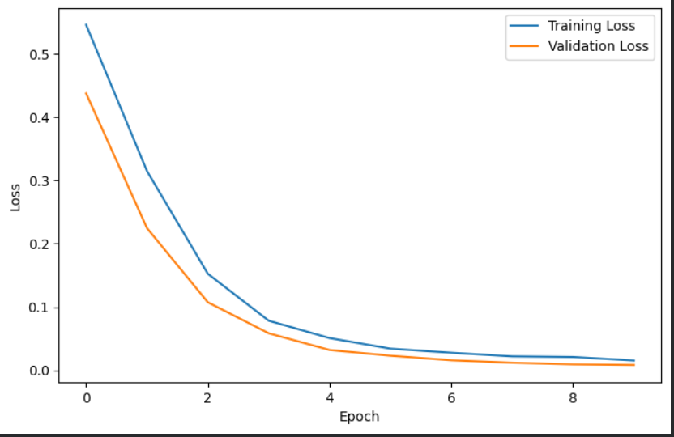

Observations-

Word embeddings capture the meaning of the text better than simple numerical features.

Some paragraphs with similar meanings were still difficult for the model to classify correctly.

Conclusion-

This task showed that semantic embeddings improve text representation and help the neural network classify text more effectively. The model learned meaningful language patterns for AI detection.

Task 2 – Tier C Report (The Transformer)

The objective of this task is to fine-tune a DistilBERT model using LoRA to detect whether a paragraph is human-written or AI-generated.

Loaded the prepared text dataset.

Tokenized the text using the DistilBERT tokenizer.

Fine-tuned the DistilBERT model using LoRA.

Trained the model on the training dataset.

Evaluated the model on the test dataset using accuracy and other performance metrics.

Tools Used-

DistilBERT

Transformers

LoRA

PyTorch

Results-

The transformer model learned complex language patterns from the dataset.

It achieved better performance than traditional machine learning models.

The evaluation results showed that the model could effectively detect AI-generated text.

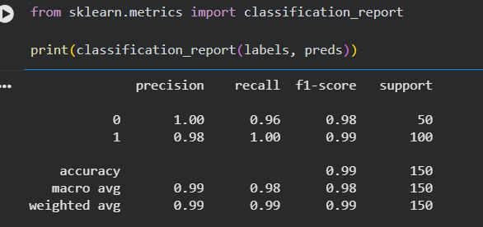

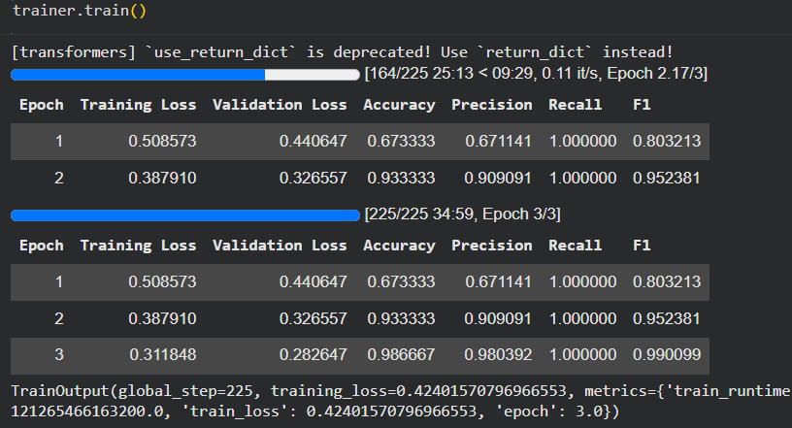

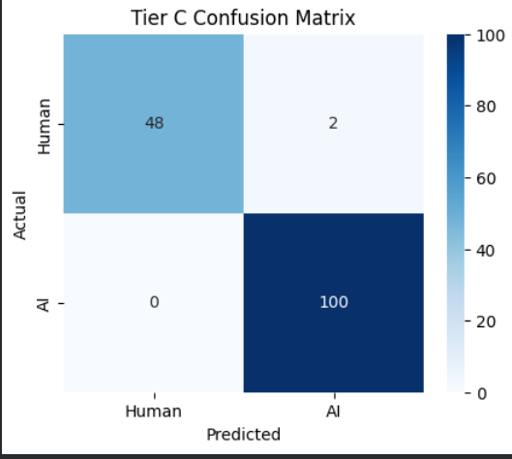

Observations-

Transformer models understand both writing style and sentence meaning.

They require more training time and computing resources than the previous models.

Conclusion-

This task demonstrated that transformer models are highly effective for AI text detection. Fine-tuning DistilBERT with LoRA improved the model's ability to distinguish between human-written and AI-generated text while reducing training cost.

Task 3 Report – The Smoking Gun

The objective of this task is to understand why the AI detection model predicts a text as AI-generated or human-written. Instead of checking only the prediction, we also analyze which words and writing patterns influence the model's decision.

Steps Performed-

Loaded the fine-tuned DistilBERT model from Task 2.

Loaded the tokenizer and required libraries.

Used the Captum library to generate word importance (saliency) scores.

Selected a sample paragraph and passed it through the model.

Highlighted the words that had the highest influence on the prediction.

Performed error analysis by finding human-written paragraphs that were incorrectly classified as AI-generated.

Tools Used-

DistilBERT

Transformers

Captum

PyTorch

Results-

The model successfully highlighted the important words that affected its prediction.

Saliency visualization helped identify which parts of the paragraph were most influential.

During error analysis, 3 human-written samples were wrongly classified as AI-generated (false positives).

These samples contained repetitive and highly structured writing, making them appear similar to AI-generated text.

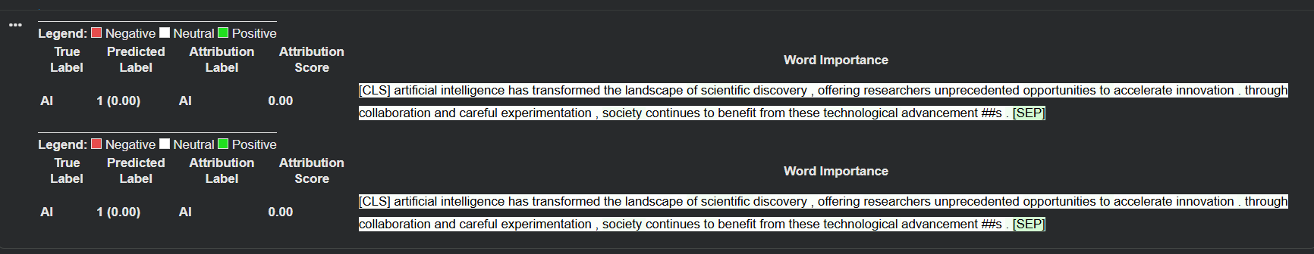

Observations-

The model does not depend on a single word. It also considers sentence structure and writing style.

Some human-written paragraphs can look similar to AI-generated text, which leads to incorrect predictions.

Saliency mapping improves the understanding of how the model makes its decisions.

Conclusion-

This task helped explain the model's predictions instead of only checking whether they were correct. The saliency maps showed which words influenced the decision, and the error analysis showed that some human writing can still be mistaken for AI. This gives a better understanding of the model's strengths and limitations.

Task 4 Report – The Turing Test

The objective of this task is to improve an AI-generated paragraph so that the AI detector predicts it as human-written. A Genetic Algorithm (GA) was used to gradually modify the text and improve its human probability score.

Steps Performed-

Loaded the trained AI detection model from Task 2.

Generated AI-written paragraphs using Gemini.

Calculated the human probability score for each paragraph.

Selected the best-performing paragraphs.

Used Gemini to rewrite the selected paragraphs by changing sentence flow, wording, and writing style while keeping the meaning the same.

Repeated this process for multiple generations and recorded the score after each generation.

Finally, tested a manually written paragraph to compare the AI score before and after humanization.

Tools Used

Gemini API

DistilBERT

LoRA

Transformers

PyTorch

Results

The Genetic Algorithm successfully generated improved versions of the AI-written paragraphs.

The human probability score changed after each generation, and the best paragraph achieved a higher human score than the initial versions.

The manually written paragraph was also tested before and after editing to observe how the detector responded.

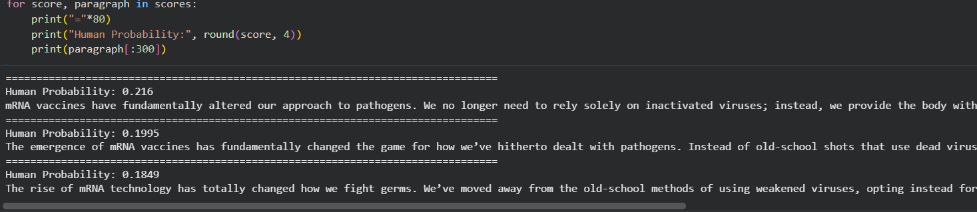

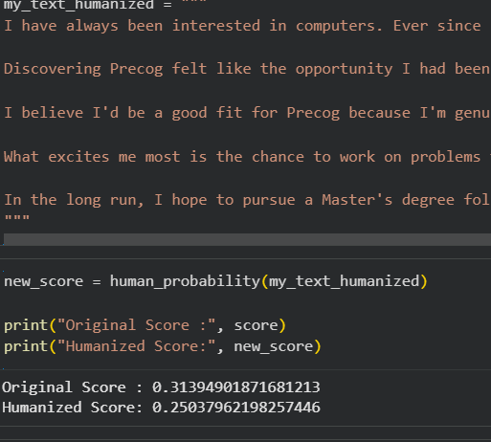

Observations

Small changes in sentence structure and writing style affected the model's prediction.

Using different wording and more natural sentence flow helped increase the human probability score.

The detector still identified many rewritten paragraphs as AI, showing that bypassing the model is challenging.

Conclusion

This task showed how a Genetic Algorithm can be used to improve AI-generated text step by step. Although the rewritten paragraphs became more human-like, the detector was still able to identify many of them as AI-generated. This experiment helped us understand both the strengths and the limitations of the AI detection model.

